Covid-19 Reinfections Are Rare, Although More Common in Older Adults
https://www.pharmacytimes.com/view/study-covid-19-reinfections-are-rare-although-more-common-in-older-adults

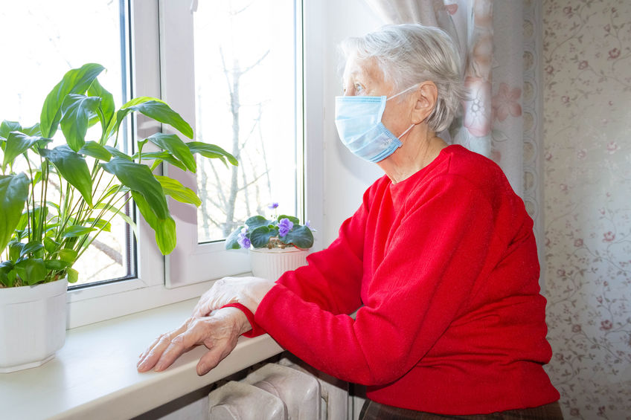
Although prior infection with COVID-19 protects most people against reinfection, new data has shown that people over 65 years of age have a greater risk of reinfection; older adults have shown to only have 47% protection against repeat infection compared to 80% protection for those who are younger. The data was collected and analyzed in Denmark and included more than two-thirds of the population. Denmark’s healthcare data is centralized, and as a part of the country’s efforts to control COVID-19, free PCR testing was offered nation-wide to everyone. This availability of data at such a large scale separates this study from others due to the sheer population size and permits for the unique opportunity to analyze truly diversified data. Data spanned the first and second major “waves” of COVID-19 infections; however, it is important to note that this data only includes the original COVID-19 strain as researchers were unable to analyze the data in regard to COVID-19 variants. These results highlight the important of protecting older adults during the pandemic, even in those who have already recovered from COVID-19. Additionally, this data suggests that those who have had the virus should still be vaccinated as natural protection may not be enough, particularly in older adults.

