FDA Approves First Oral Selective 5HT1A Receptor Agonist for MDD

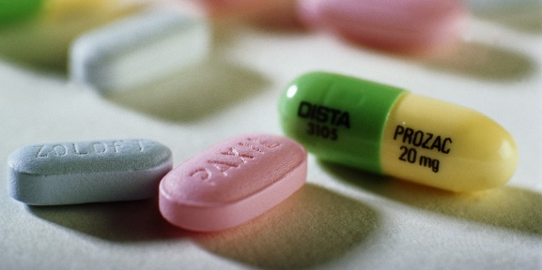
For decades, serotonin modulation has been a mainstay of treatment for Major Depressive Disorder (MDD.) However, patients starting SSRIs (Selective Serotonin Re-uptake Inhibitors) can expect to wait several weeks for the medication to take effect. SSRIs, such as Zoloft and Prozac take time to work because neuronal receptors involved in preventing excess serotonin levels will initially up-regulate. After several weeks, these receptors become desensitized, allowing for a net effect of higher serotonin levels. Many patients may be given other short-acting medications temporarily, that can result in dependence or worsening of mood. Alternatively, patients who are simply waiting for the SSRI to take effect may be experiencing suicidal thoughts or suffering unnecessarily.
Because SSRIs are selective for other receptors in the body, a patient may experience gastrointestinal side effects, dry mouth, sleep disturbances, and more upon initiation or dose increase. Long-term side effects may include sexual dysfunction and weight gain. These undesired effects often result in perceived failure or non-adherence.
A new first-in-class serotonin modulator, EXXUA (gepirone ER) tablets was FDA-approved in September 2023 and will be available this year as an alternative. EXXUA is a specific 5-HT₁A receptor agonist, belonging to the buspirone family. Instead of promoting reuptake inhibition of serotonin, EXXUA directly increases 5-HT₁A post-synaptic receptor activity for a more immediate effect. Greater selectivity also means weight gain and sexual dysfunction can be avoided. For patients in long-term care, the reduced wait-time for effect could be helpful.
EXXUA’s most common short-term side effects included dizziness, nausea, insomnia, abdominal pain, and dyspepsia. It is contraindicated in patients with a prolonged QT interval (QTc > 450 ms at baseline) or QT syndrome, so an ECG is suggested prior to initiation. Other contraindications include concomitant use with CYP₃A₄ inhibitors, MAOi within 14 days, or severe hepatic impairment. Patients with a moderate CYP₃A₄ inhibitor, the elderly, or those with renal or non-severe hepatic impairment may take EXXUA at a reduced dose.
EXXUA’s manufacturer, Fabre-Kramer also has two other phase trials in pipeline to gain FDA-approval for its drug to treat Generalized Anxiety Disorder and Hypoactive Sexual Desire Disorder. EXXUA may not become a first-line therapy to replace SSRIs anytime soon, but it could offer an alternative to SSRIs.
Article Link: FDA Approves First Oral Selective 5HT1A Receptor Agonist for MDD (psychiatrictimes.com)
Image Link: SSRIs and Antidepressants Increase Mental Health Issues Confirmed - Activist Post

